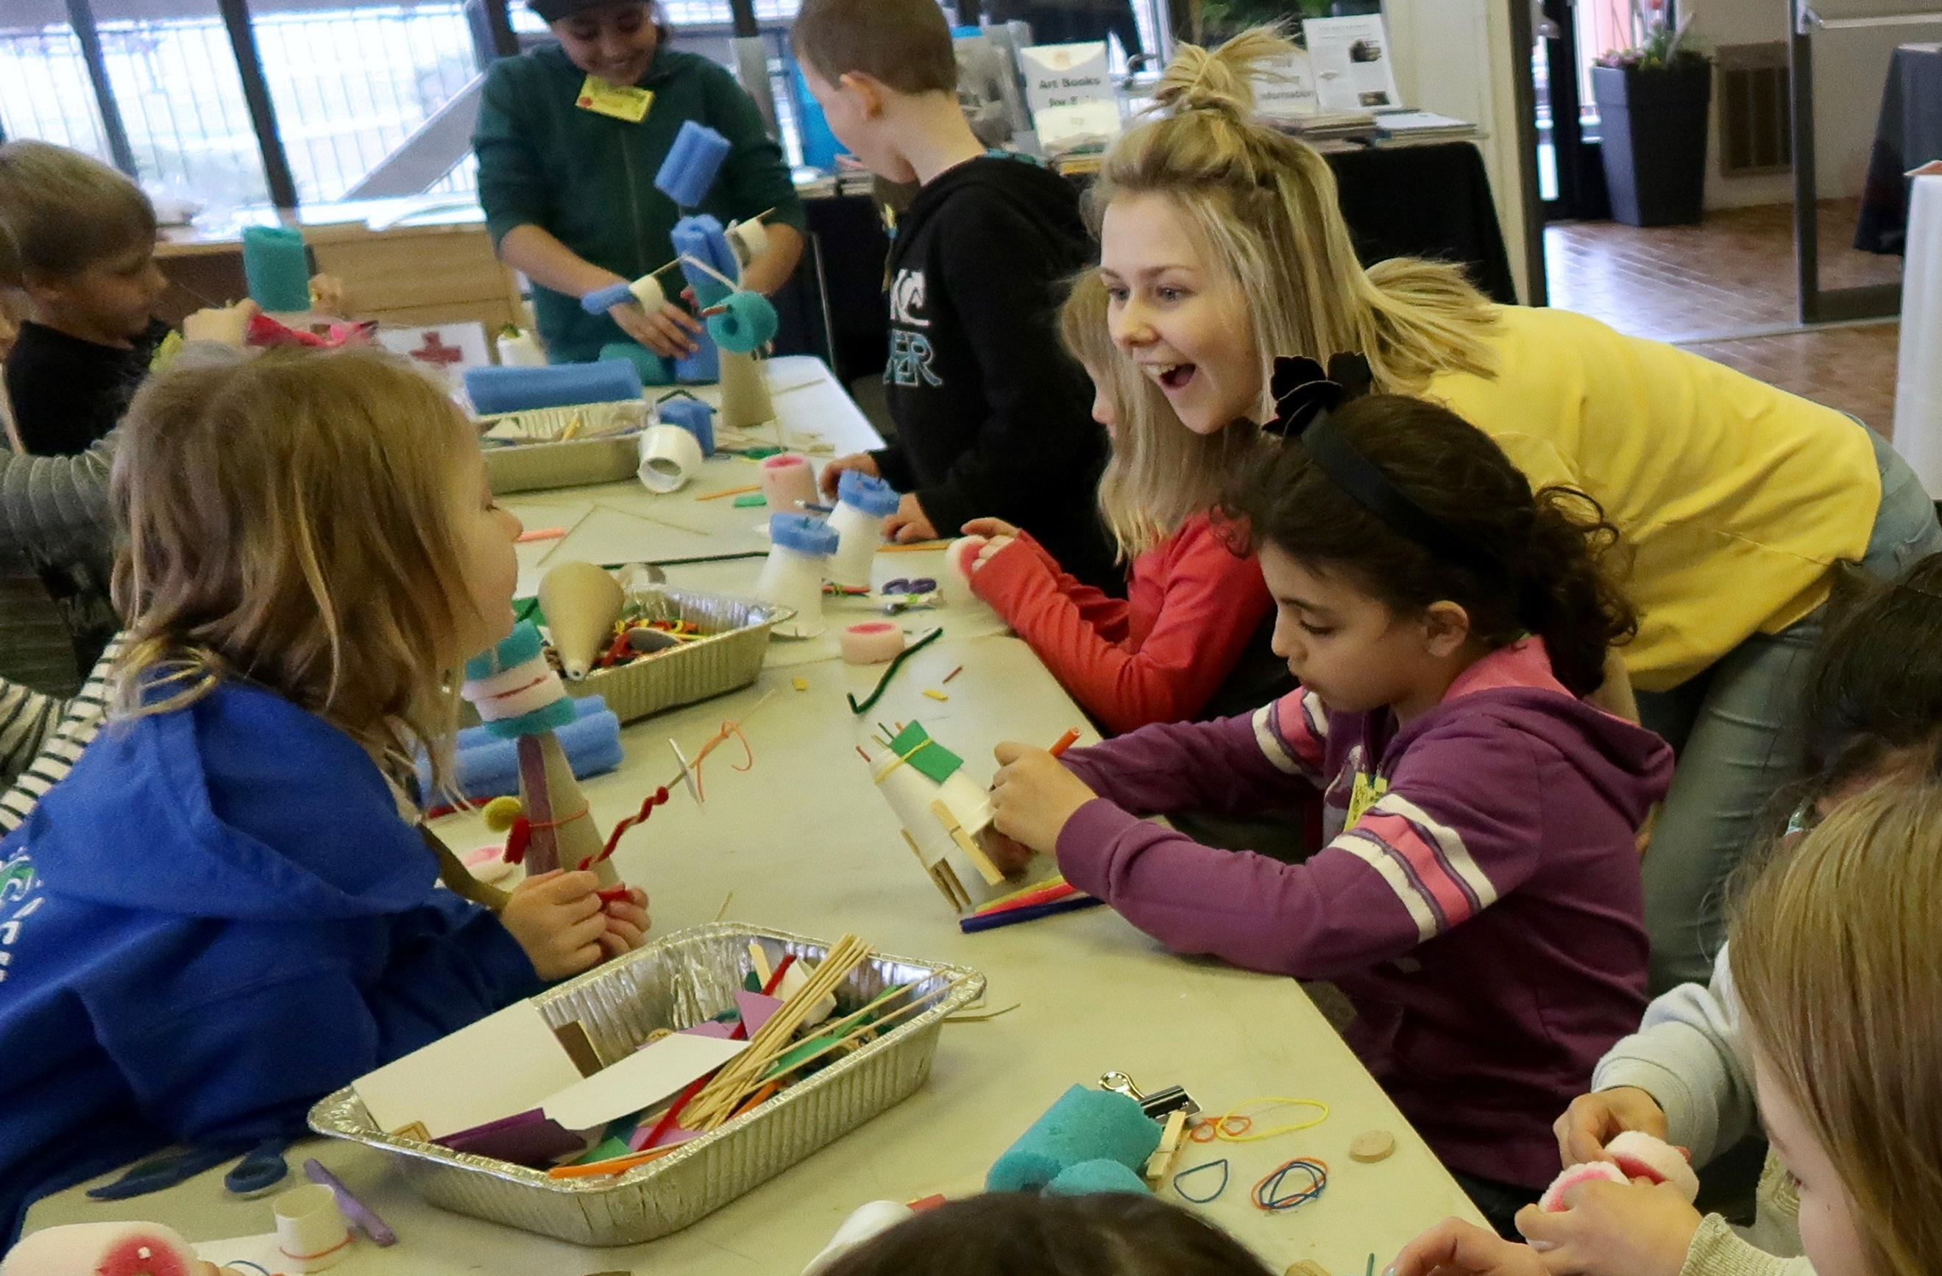
SUMMERLAND MUSIC CAMP
JULY 8-12, 2024

YOUTH LEADER JOB DESCRIPTION
Summerland Music Camp is a five-day camp for 7-11 year-olds, 8:30am-12:30pm Monday to Friday. The ukulele, singing, art and dance sessions are run by experienced adult leaders. Here’s what the youth leaders are expected to do:
- Be part of the team of leaders working to make the camp great!
- Attend a training session a week before camp (possible dates listed on our web site)
- Arrive at 8:00 am every morning for the morning team meeting
- Sign in the children as they come, greet them and interact with the children of your small group to set the tone for the day
- Accompany the children to all activities
- Participate in all activities as helpers for the adult leaders and the children
- Help the children with social skills and activity skills, guiding and encouraging their participation Note any concerns and share with the adult team
- Clean up at the end of the morning
- Contribute to the debrief/discussion sessions with the full team afterwards over lunch. Discuss, problem-solve, encourage each other (approximate ending time Mon-Thurs: 1:30 pm)
- Attend the closing potluck lunch on Friday after camp (12:30-1:30pm)
- Help with the final clean up on Friday: leaders are expected to stay until everything is done (maximum 4:00 pm)
- Make the camp a happy, positive experience for the children!
Qualifications:
- Ages 13 – 18
- Have a heart for children. Some previous experience working with children is helpful
- A positive attitude and a willingness to take part in everything
- It is not necessary that you be experienced in music, ukulele, dancing or art (that’s what the adult leaders are for) but you must be willing to join in doing and helping
You are an integral part of the camp and we could not do this without your wholehearted and enthusiastic participation!
Ms. Linnea and Ms. Betty-Ann

Summerland Music Camp 2024 Coordinators
ArtSpiritSummerland.com
Lg@LinneaGood.com

